Requirement Document- AP

Prepared By : Swathi

Reviewed By : ALAN,GOKUL,VASAN

Proprietary Notice

The information contained in this document is of a proprietary nature. The disclosure, duplication, use in whole, or use in part, of the proposal for any purposes without the written permission of Logiware is prohibited.

Account Payable - Reconcile Screen

Given Layout Design:

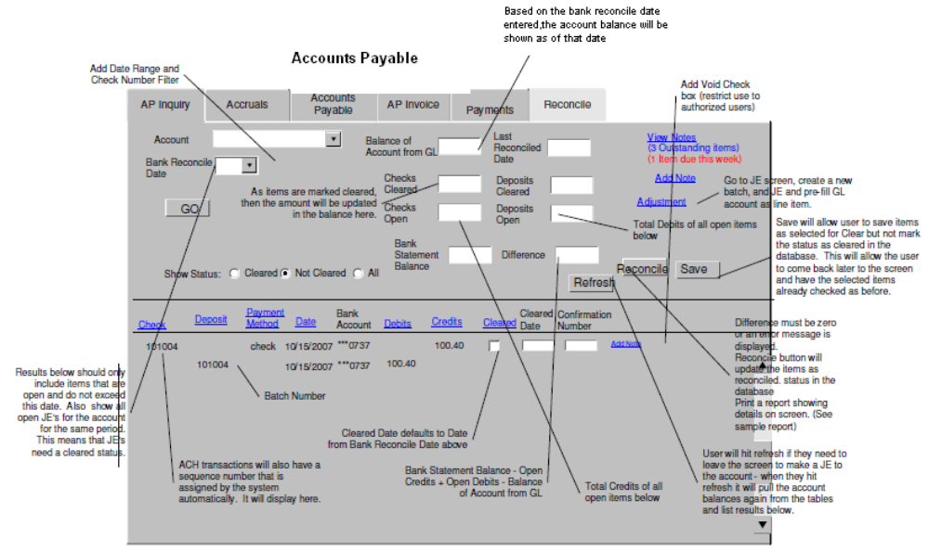

Clarification Required:
1.
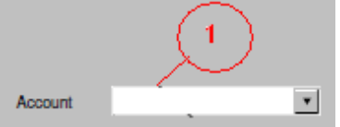

- What values should the account number fetch here and based on which status .Does it means to fetch the GL Account number? Need clear details..

2.
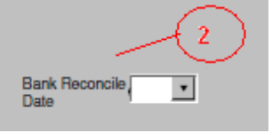
- Mentioned to add Date Range and Check Number Filter. What is Check Number Filter
Need more details on this.

3.
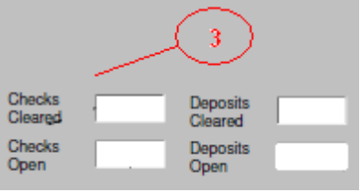

- Mentioned that when status is cleared then all of the above fields should be filled automatically with some balance amount.
What amount should be displayed in 'Checks Cleared' and 'Deposits Cleared' fields.
Similarly with 'Checks Open' and 'Deposits Open' fields. From which table the values are fetched .Need Details..

4.
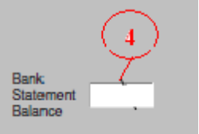

- What values should this 'Bank Statement Balance' field display. Is it related with the statuses
as mentioned in the document such as Cleared ,Not Cleared and All
Need more details.

5.
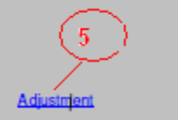

- Onclick of this button should the screen navigate from the current ' Reconscile ' screen to JE screen literally and allow the user to create a new batch and prefill GL account as line items. Need more detailed clarification.

6.

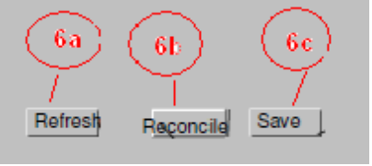
- The 3 buttons are mentioned in the screen shots.
(6a).Refresh → action to be performed onclick of this button is not clear.
(6b).Reconcile → Mentioned that the difference amount should be zero or error message should be displayed. Also mentioned to update DB with the status 'reconciled' and generate the print.
Need the print design and the conditions when the status should be updated ,
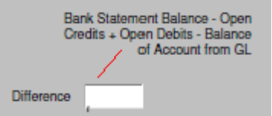
and more clarification on 'Difference' amount while the formula is given to get it as in above screen shot.
Need more clear details.

(6c).Save → To which table the status should be updated? Do this consists of any new table structure on the whole for this entire screen. Need more details on the functionalities to performed when the save button is clicked.

7.
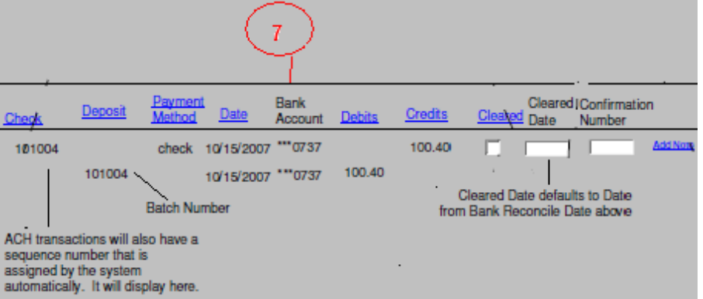
- The above screen shot describes the display format.
Check → what value should be displayed for this and what is sequence number assigned by the system. Need details.
- Confirmation Number → is this a text box allowing manual entry ,if not what values should this display. Need details.
- All the other fields currently relate to different table,so is there any single table structure so that all these values can be fetched.
Need clarification.

8. Notes : Details required.

